Soccer Jersey

My web interface supposed to be an online Soccer jersey store which will give you a list of jersey’s and will allow you to simply pick a favorite jersey and order.

You suppose to have 10 different type of jersey from 10 different clubs and their price is set according to their winning status.

The app will show you all ten jersey’s and you can select any one of the jersey’s or multiple.

I finally decided to do a web app api that is different from my proposal. I had a hard time to make the web app to work as I been looking at the lecture videos. However, I couldn’t get my MongoDB to connect with my files in the node.js folders. I have failed in postman where it supposes to create a special Id when _Id is passed through route.post in my jerseys.js file.

Because, my MongoDB was not able to connect via mongoose, I was not successful to create the appropriate website. However, I do understand how these functionalities are working. How request is giving, and an id will be created via by mongoose and will give back what the client or customer ordered to the back end.

Npm start is running properly

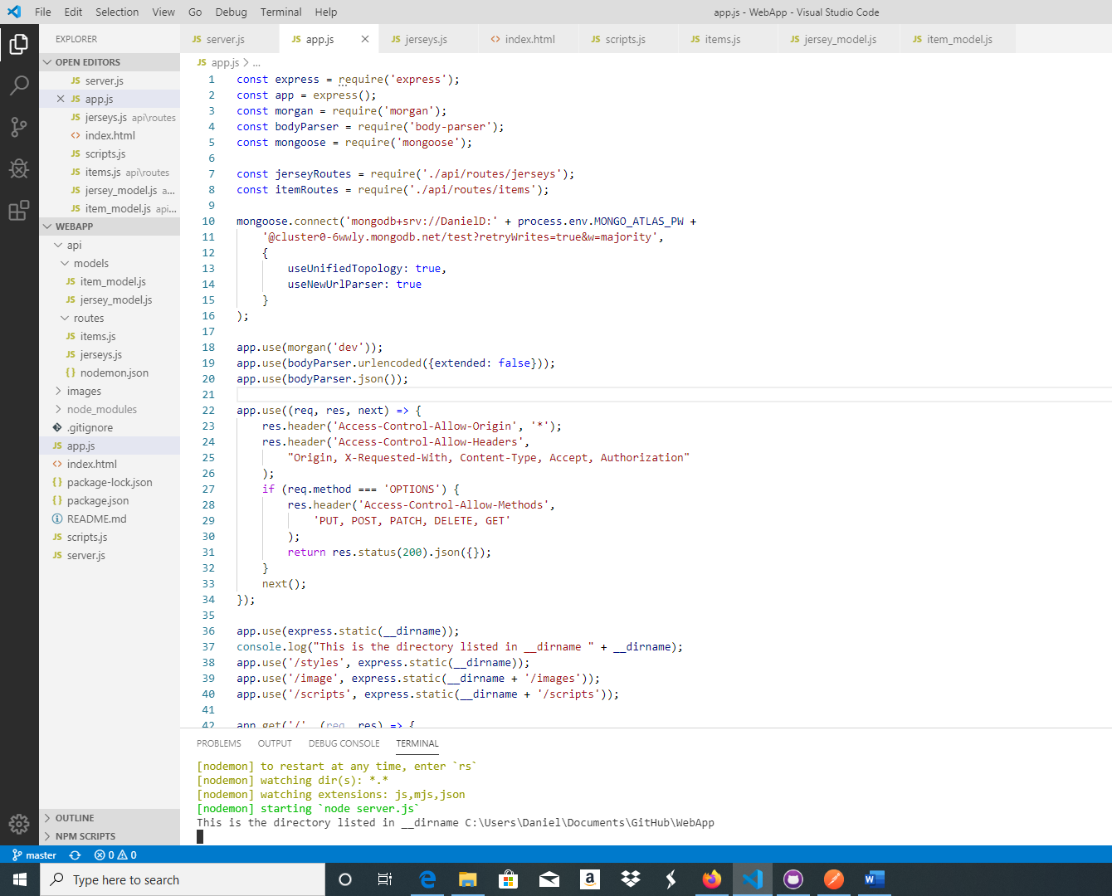

Postman [CRUD]

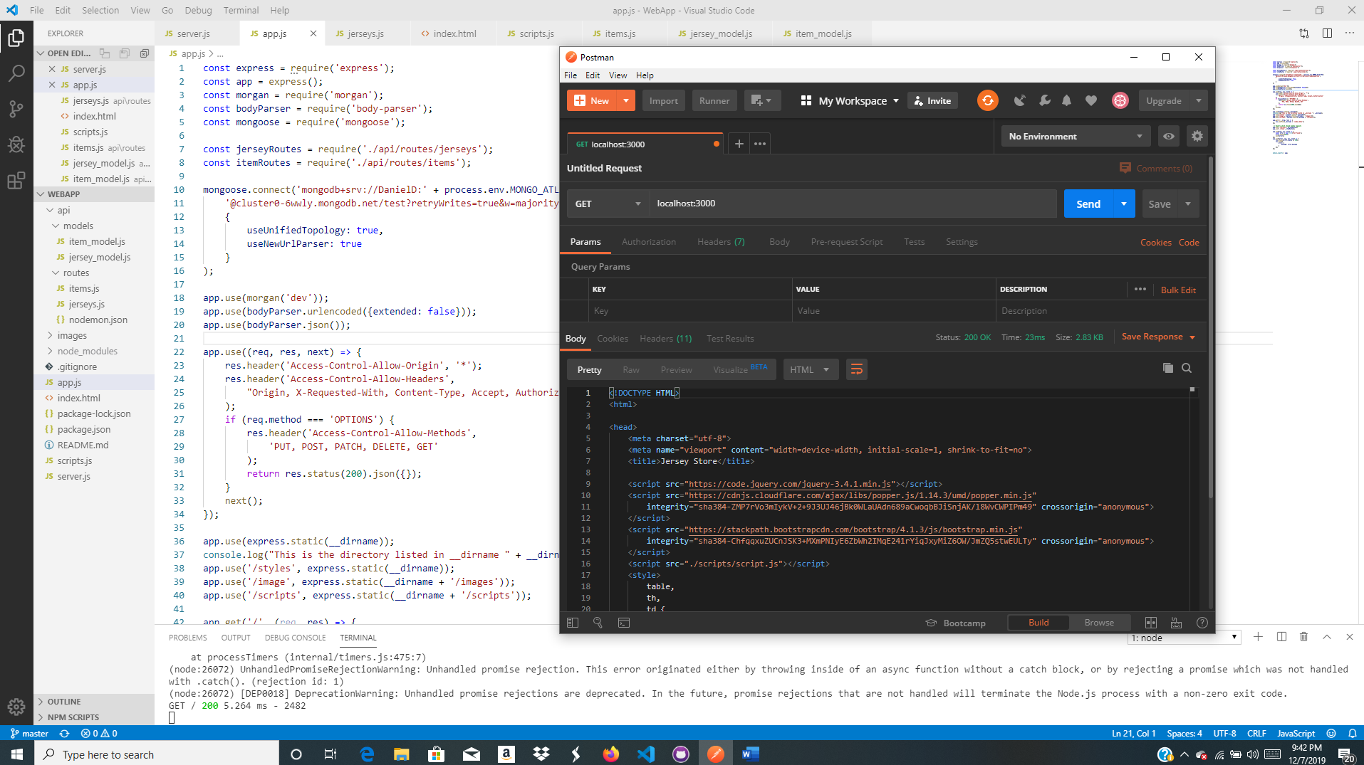

This is where postman in now creating that special id for the order

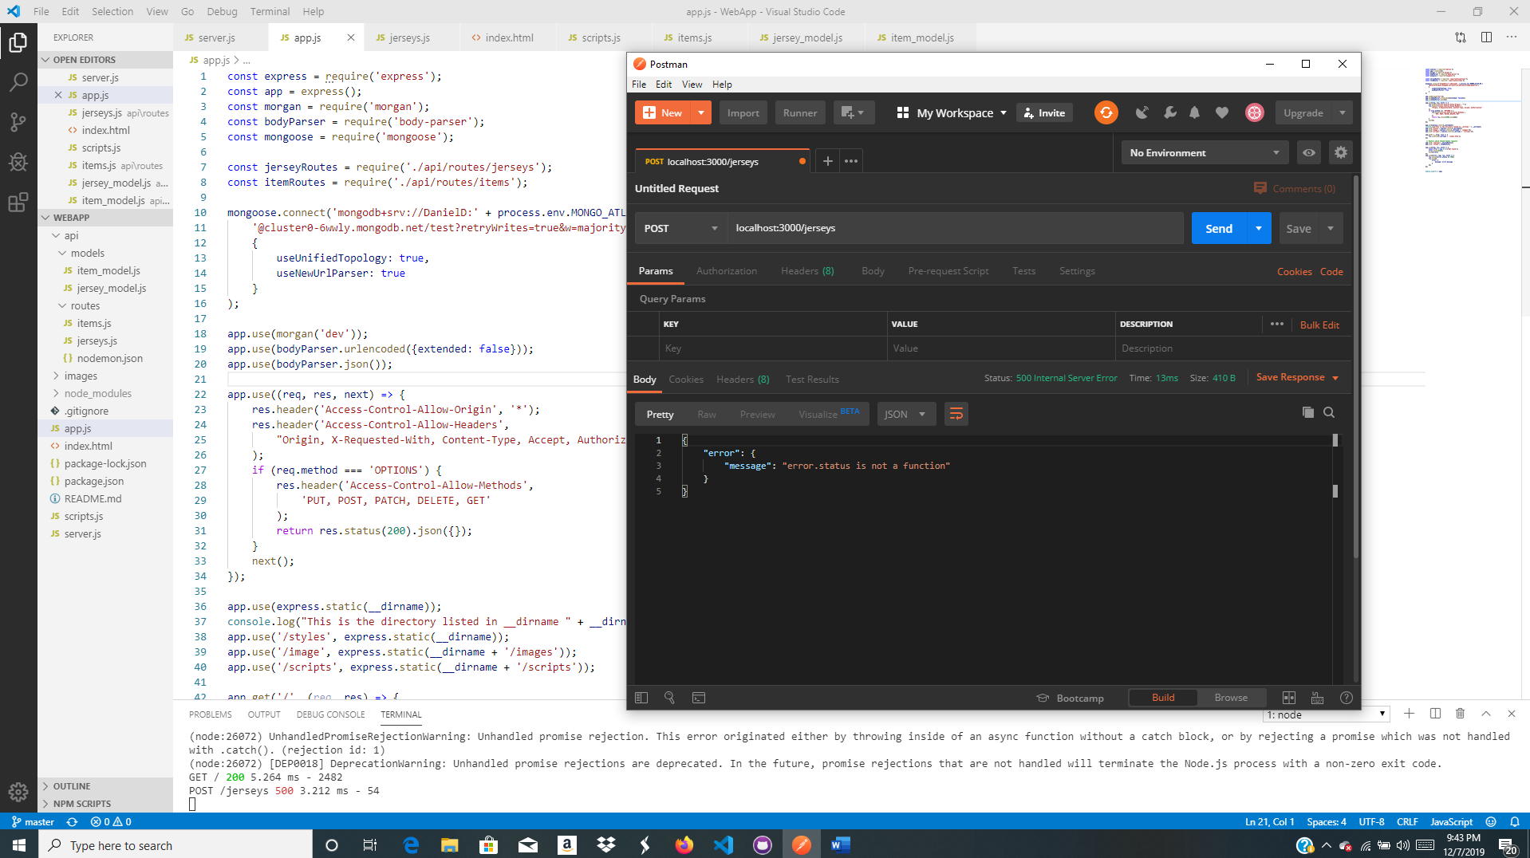

MongoDB

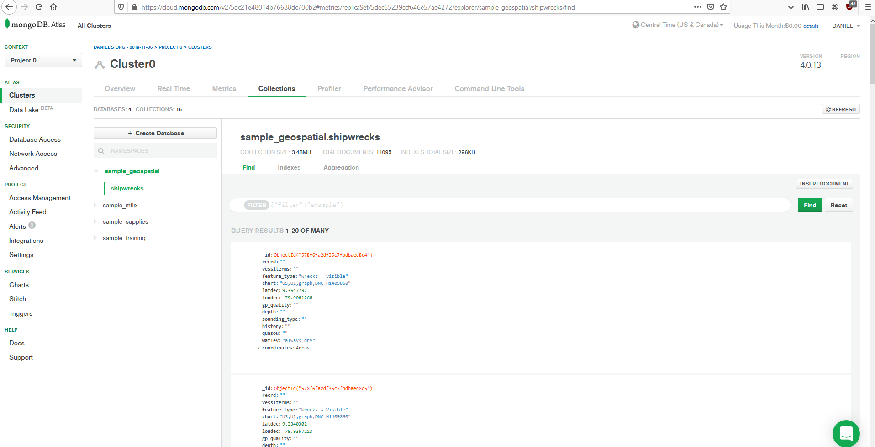

No connection at all

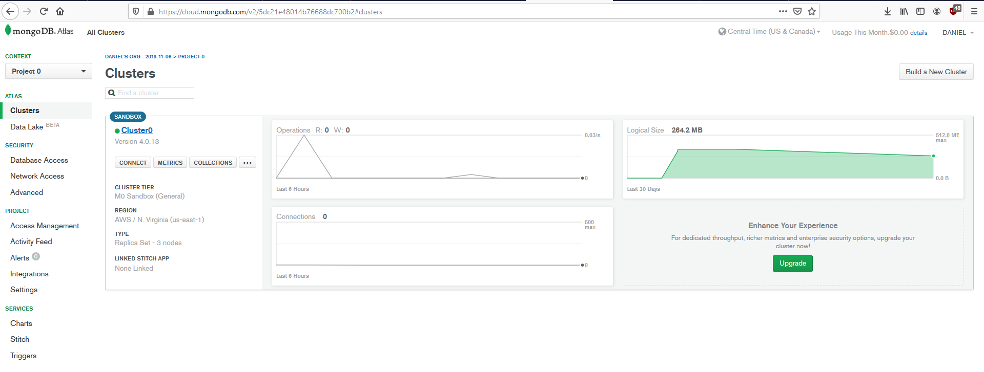

Localhost:3000/

